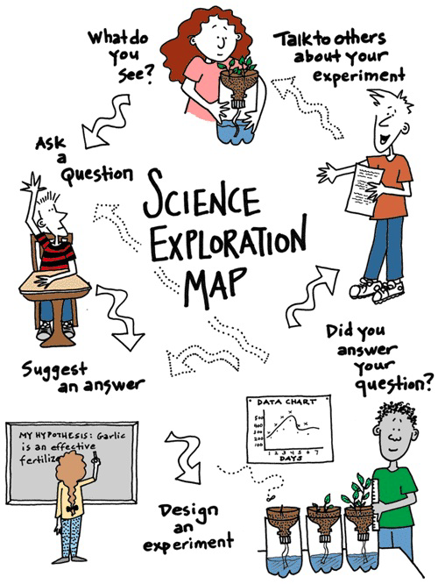

& collect data

TEAM



& collect data

TEAM